

**ANKARA YILDIRIM BEYAZIT UNIVERSITY   
FACULTY OF ENGINEERING AND NATURAL SCIENCES**

**ENHANCING INTERDEPARTMENTAL COLLABORATION AT HAVELSAN: HOLISTIC SYSTEM DESIGN FOR DATA FLOW AND COMMUNICATION USING TRIZ, LEAN, AND AGILE METHODOLOGIES**

**Undergraduate Thesis By   
Merve Nur Halaç - 20050311012**

**Nuran Kocabey - 20050311035**

**Department of Industrial Engineering**

**January, 2025**

**ANKARA**

**ENHANCING INTERDEPARTMENTAL COLLABORATION AT HAVELSAN: HOLISTIC SYSTEM DESIGN FOR DATA FLOW AND COMMUNICATION USING TRIZ, LEAN, AND AGILE METHODOLOGIES**

**A Thesis Submitted to**

**The School of Engineering and Natural Sciences of Ankara Yıldırım Beyazıt University In Partial Fulfillment of the Requirements for the Degree of Bachelor of Science of Philosophy in Industrial Engineering, Department of Industrial Engineering**

**By**

**Merve Nur Halaç and Nuran Kocabey**

**Advisor**

**Deniz EFENDİOĞLU, PhD.**

**Jan , 2025**

**ANKARA**

**B.Sc. THESIS EXAMINATION RESULT FORM**

We have read the thesis entitled “Enhancing Interdepartmental Collaboration at Havelsan: Holistic System Design For Data Flow And Communication Using Triz, Lean, And Agile Methodologies” completed by Merve Nur HALAC and Nuran KOCABEY under supervision of Asst. Prof. Dr. Deniz Efendioğlu and we certify that in our opinion it is fully adequate, in scope and in quality, as a thesis for the degree of Bachelor of Science.

_______________________

**Asst. Prof. Dr. Deniz Efendioğlu**

Supervisor

_______________________

Jury Member

_______________________

Jury Member

# ETHICAL STATEMENT

In this thesis study that we prepared in accordance with Yıldırım Beyazıt University Institute of Science and Technology Thesis Writing Rules;

· We obtained the data, information and documents we present in the thesis within the framework of academic and ethical rules,

· We present all information, documents, evaluations and results in accordance with scientific ethics and moral rules,

· Wecite all of the works I used in my thesis with appropriate references,

· We have not made any changes to the data used,

· The work we present in this thesis is original,

We hereby declare that we accept all losses of rights that may arise against me in any other case.

**06/01/2024**

**Merve Nur HALAC**

**Nuran KOCABEY**

# ACKNOWLEDGEMENTS

We would like to express our deepest gratitude to our valued advisor Assoc. Prof. Dr. Deniz Efendioğlu for her unwavering support, insightful guidance and constant encouragement throughout the development of this project. Her expertise and dedication were invaluable and it was a privilege to learn under her guidance. This journey was both inspiring and enriching thanks to her enthusiasm and commitment.

**06/01/2024**

**Merve Nur HALAC**

**Nuran KOCABEY**

# ABSTRACT

A key component of organizational success is efficient interdepartmental communication, particularly for large, complex organizations like HAVELSAN. This paper examines the difficulties and inefficiencies in communication at HAVELSAN, one of Turkey's top defense and technology companies, and suggests a comprehensive way to improve cooperation and data flow. Leveraging TRIZ (Theory of Inventive Problem Solving), Lean, and Agile approaches, the research highlights major communication gaps, such as dependency on manual processes, lack of centralization, and poor feedback channels.

The project employs structured approaches to streamline workflows, standardize data-sharing protocols, and foster collaboration across departments. Specifically, TRIZ principles guide innovative solutions to address contradictions in communication systems, while Lean focuses on eliminating inefficiencies, and Agile introduces iterative and flexible implementation strategies. By integrating these methodologies, the proposed framework aims to create a centralized, automated, and resilient communication system tailored to HAVELSAN's strategic objectives.

The findings highlight the significant impact of improved interdepartmental communication on organizational efficiency, decision-making processes, and employee satisfaction. This research not only provides actionable insights for HAVELSAN but also serves as a scalable model for other organizations facing similar challenges in their communication systems.

# CONTENTS

ETHICAL STATEMENT iii

ACKNOWLEDGEMENTS iv

ABSTRACT v

CONTENTS vi

LIST OF TABLES ix

LIST OF FIGURES x

CHAPTER 1 INTRODUCTION 1

1.1 Background of Project 1

1.2 Company Overview 2

1.3 Project Overview 2

1.4 Problem Identification 5

1.4.1 Stakeholders in the Communication Process 5

1.4.2 Fully Understanding the Communication Challenges 5

1.4.3 Identifying Communication Gaps 6

1.4.4 Impacted Processes and Departments 6

1.4.5 Development and Consequences of Communication Breakdowns 7

CHAPTER 2 CURRENT SITUATION 8

2.1 HAVELSAN Strategy Team's Communication with Other Departments 8

2.2 The Role of the Strategy Department in Communication 8

2.2.1 Strategic Coordination 8

2.2.2 Primary Communication Objectives 8

2.3 Existing Communication Tools and Protocols 9

2.3.1 Tools in Use 9

2.3.2 Communication Protocols 9

2.4 Challenges in Interdepartmental Communication 10

2.4.1 Lack of Centralization 10

2.4.2 Manual Dependency 10

2.4.3 Communication Gaps 10

2.4.4 Lack of Feedback Mechanisms 11

2.5 Effects of Current Communication Issues 12

2.5.1 Operational Delays 12

2.5.2 Increased Workload 12

2.5.3 Missed Opportunities 12

2.6 Summary of Current Situation 12

CHAPTER 3 LITERATURE REVIEW 13

3.1 What is Interdepartmental Collaboration? 13

3.2 Importance of Interdepartmental Communication 13

3.3 Challenges and Barriers to Effective Collaboration 14

3.4 How Global Organizations Manage Interdepartmental Collaboration 18

3.5. Leveraging SSADM for Improved Interdepartmental Communication and Collaboration 20

3.6 TRIZ Methodology for Strengthening Interdepartmental Cooperation 21

3.7 Lean Methodology in Communication Systems 21

3.8 Literature Gaps and Research Opportunities 22

CHAPTER 4 METHODOLOGY OVERVIEW 23

In this study, a combination of Lean, Agile and TRIZ (Theory of Resheniya Izobretatelskikh Zadach) methods will be used to solve the identified problem. Below, the main features of each methodology, their applicability and how to integrate them into our work process are summarized. 23

4.1 TRIZ (Theory of Inventive Problem Solving) 23

4.2. Lean Approach 25

4.2.1. Value Stream Mapping (VSM): 25

4.2.2. 5S Methodology: 26

4.3 Agile Methodology 27

4.3.1. Agile Performance Metrics and Their Applications 28

CHAPTER 5 CONCLUSION AND NEXT STEPS 29

REFERENCES xi

# LIST OF TABLES

**Table 1:** Level of Communication with Strategy Department 9

**Table 2:** Success factors in the implementation of Lean computing in the BT sector 27

# LIST OF FIGURES

**Figure 1:** Value Stream Map 10

**Figure 2:** Cycle of Data Flow 11

**Figure 3:** Theory of Inventive Problem Solution 24

# 

# CHAPTER 1 INTRODUCTION

## 1.1 Background of Project

This work is being carried out as a senior thesis in the Ankara Yıldırım Beyazıt University Department of Industrial Engineering. The main goal is to examine and enhance interdepartmental communication at HAVELSAN DEFENSE INDUSTRIES AND TRADE INC. a well-known defense and technology corporation. For large firms like Havelsan, where several divisions must coordinate to fulfill organizational goals, effective communication is essential to the successful operation of the business. The goal of this project is to pinpoint current communication inefficiencies and offer fixes that improve overall efficiency, decision-making procedures, and organizational effectiveness.

For the purpose of further comprehending Havelsan's communication possibilities and problems, the study has featured direct involvement with the company's strategy team. A customized solution is being created by conducting in-depth interviews with engineers and important stakeholders and by carefully examining the business's internal procedures. To guarantee sustainability and efficacy, the suggested solutions make use of approaches like TRIZ, Lean, Agile, and Structured Systems Analysis and Design Methodology (SSADM). The ultimate goal of this thesis is to support Havelsan's strategic goals and increase its operational efficiency by enhancing interdepartmental communication.

## 1.2 Company Overview

HAVELSAN was founded in 1982 as a company affiliated with the Turkish Armed Forces Foundation and is one of Turkey's leading technology companies. Based in Ankara, the company is an IT and systems company that offers global solutions in the defense and IT sectors.

HAVELSAN specializes in C4ISR (Command, Control, Communication, Computer, Intelligence, Surveillance and Reconnaissance), homeland security, simulation and training systems, and information management systems.

It also plays an active role in e-government applications, reconnaissance-surveillance and intelligence systems, logistics support, energy management systems, and cyber security projects. The company operates with various offices and subsidiaries in Turkey and abroad. HAVELSAN's product portfolio includes innovative solutions such as the BAHA unmanned aerial vehicle (UAV) and the Barkan unmanned ground vehicle (UGV). In addition, HAVELSAN is among the 500 largest industrial enterprises in Turkey and has achieved significant success in defense industry projects.

## 1.3 Project Overview

In today’s business world, interdepartmental communication has become a critical factor that directly impacts the efficiency and effectiveness of an organization. Each department specializes in its functional domain and typically focuses on specific objectives. However, achieving these objectives in alignment with the company’s overall strategy requires a robust communication network between departments. Effective interdepartmental communication enhances not only the flow of information but also organizational collaboration and problem-solving processes.

Interdepartmental communication ensures the seamless operation of a company’s processes. Particularly in areas such as product development, marketing, finance, human resources, and logistics, accurate information sharing among departments contributes to reducing errors and accelerating workflows. In this context, interdepartmental communication emerges as a fundamental element in improving overall organizational efficiency and service quality. Moreover, the effectiveness of such communication directly influences customer satisfaction, especially when there is a need to respond promptly and accurately to customer demands.

In organizations where interdepartmental communication is ineffective, disruptions in the flow of information, misunderstandings, and process disconnects frequently occur. These issues often lead to difficulties in mutual understanding among employees and delays in operations. Additionally, internal isolation within the company negatively impacts employee motivation and collaboration. As the size of the company and the complexity of its operations increase, the importance of interdepartmental communication becomes even more pronounced.

To ensure the collaborative efforts necessary for achieving objectives, companies often employ tools such as centralized communication platforms, regular meetings, surveys, and feedback systems. However, for these tools to be effectively utilized, it is essential to understand the specific needs of each department and to encourage all employees to actively engage with these platforms. Insufficient participation and disruptions in information sharing can pose significant threats to the success of the organization’s overall strategy.

Studies have consistently shown the importance of organizational structure in business performance and decision-making. Wally and Baum (1994) found that centralized organizations make faster strategic decisions, while formal structures slow down decision-making. Molchanov et al. (2019) emphasized that decision-making complexity increases with organizational complexity, affecting resource intensity and decision quality. Ajagbe et al. (2016) emphasized the strong relationship between organizational strategy and structure, indicating that appropriate fit leads to improved performance. Baum and Wally (2003) showed that strategic decision speed mediates the relationship between environmental and institutional characteristics and firm performance, with faster decision-making predicting better growth and profitability. Their study also confirmed that centralization and formalization affect decision speed. These findings underscore the critical role that organizational structure plays in shaping decision-making processes and ultimately in affecting business success in dynamic environments.

The organizational structure in businesses is a fundamental element for achieving success and efficiency. A structure aligned with the company’s strategy enables rapid responses to change while providing a flexible system free of bureaucratic obstacles. This structure not only organizes relationships between employees and tasks but also accelerates decision-making processes. As Fayol emphasized, organizational structure consolidates the essential elements for sustaining business operations. Moreover, modern approaches highlight the importance of customer-oriented and agile systems. A well-designed organizational structure is crucial for businesses to succeed in competitive environments.

Fostering collaboration, improving decision-making, and accomplishing corporate objectives all depend on effective interdepartmental communication. Without it, delays, misunderstandings, and inefficiencies can seriously impair organizational performance. Effective communication is even more important for big companies like Havelsan, whose intricate operations necessitate smooth cooperation. Improving Havelsan's communication dynamics is essential to raising output, effectiveness, and general performance. In order to ensure alignment with Havelsan's strategic objectives and promote sustainable organizational growth, this study intends to develop and implement creative, workable solutions that improve interdepartmental communication.

Through the application of TRIZ, Lean, Agile, and Structured Systems Analysis and Design Methodology (SSADM), the project aims to create novel, workable, and expandable enhancements to Havelsan's organizational structure.

Finding the underlying reasons of communication inefficiencies, putting forward a framework for smooth information flow, and improving decision-making procedures through automated data sharing and reduced manual intervention are the main goals of this study. The investigation guarantees the sustainability and resilience of the suggested solutions by utilizing these approaches. The methods used, the results of the literature study, and the problem identification process—which includes a planned survey to obtain useful information—are all described in this paper. The goal of these initiatives is to help build a flexible, customer-focused company that can meet Havelsan's strategic requirements and improve overall organizational effectiveness.

## 1.4 Problem Identification

Interdepartmental communication within the company has become inefficient due to several reasons: email-based communication causes delays in accessing data and errors stemming from human mistakes; local data storage creates access restrictions for different units; repeated data requests lead to workforce inefficiency; and varying data versions result in inconsistencies and errors.

### 1.4.1 Stakeholders in the Communication Process

Interdepartmental communication is a complex process that directly affects the effectiveness of organizational processes. In this process, each department plays an active role in its interactions with other departments. Communication covers a series of activities that require the exchange of information, decision-making processes and cooperation between departments. The communication path chosen by each department and the actions taken directly affect the efficiency and responsiveness of the process. Misunderstandings or errors in communication can weaken organizational efficiency and cause processes to fail. In addition, the skill level, motivation and workload distribution of department employees are important factors that affect the effectiveness of the communication process. If employees are insufficiently skilled or unmotivated, there may be interruptions in communication, which reduces overall efficiency and slows down decision-making processes. Workload imbalance can also cause overload in some departments, disrupting the effectiveness of the process

### 1.4.2 Fully Understanding the Communication Challenges

Problems in communication between departments can have a serious impact on the efficiency of organizational processes. This study focuses specifically on how communication deficiencies and inadequacies in information sharing increase organizational costs. Lack of effective information sharing between departments prevents organizational goals from being achieved and leads to misunderstandings among employees. Lack of communication in critical decision-making processes causes loss of time and errors, which can lead to negative outcomes such as customer dissatisfaction and weakening of brand value. At this point, one of the main reasons is the lack of a common communication platform throughout the organization and the independent action of each department. As a result, information flow is interrupted and productivity decreases.

### 1.4.3 Identifying Communication Gaps

Interdepartmental communication problems usually occur during the most intensive and critical processes of the organization. Communication deficiencies become more apparent when information is not shared or cooperation is not provided between departments. These problems are especially felt in projects that require a lot of coordination between departments and in situations where urgent decisions need to be made. Newly established or growing organizations may experience such problems more intensely due to changes in the workforce and interruptions in the flow of information between different departments. In addition, seasonal workforce changes or transitions between departments can increase communication disruptions. An imbalance of workload between departments also leads some employees to focus only on the goals of their own departments, which negatively affects cooperation.

### 1.4.4 Impacted Processes and Departments

Interdepartmental communication gaps have major impacts on the overall functioning of the organization. Deficiencies in information flow cause processes to take longer and necessary information to be accessed on time. This situation manifests itself with negative results such as customer demands not being met, tasks being delayed and brand value being weakened. For example, if a department does not have the right information, customer needs may not be met on time. This can lead to customer dissatisfaction, negatively affect customer loyalty and reduce the brand's market share. Lack of communication also results in costly results such as operational errors and repetitive work.

### 1.4.5 Development and Consequences of Communication Breakdowns

Interdepartmental communication deficiencies become more complex over time and disrupt workflow. This reduces the efficiency of the organization and harms other business processes. Communication failures also lead to extra labor costs and time losses. This situation causes projects to not be completed on time because of poor information sharing among employees. Such communication problems directly affect organizational efficiency and reduce profit margins. Additional costs such as delays, errors and rework occur. As a result, the overall profitability of the organization decreases and productivity decreases. Such problems can also damage the motivation of employees, which can lead to organizational failure.

# CHAPTER 2 CURRENT SITUATION

## 2.1 HAVELSAN Strategy Team's Communication with Other Departments

The strategy department at HAVELSAN serves as a focal point for coordination of data flow, communication, and cooperation with executive board, senior management, quality and process management, international business development, financial management, human resources, project control office, and research and development. These exchanges are essential for preserving operational effectiveness, optimizing decision-making, and guaranteeing alignment with HAVELSAN's corporate goals.

## 2.2 The Role of the Strategy Department in Communication

### 2.2.1 Strategic Coordination

The strategy department acts as the backbone of corporate communications, consolidating information from various departments and ensuring alignment with corporate goals. Its main tasks include:

The strategy department functions as the backbone of organizational communication, combining information from various departments and ensuring alignment with corporate objectives. Its principal duties consist of:

-Gathering, evaluating, and disseminating departmental information.

-Using feedback loops and organized reporting to aid in decision-making.

-Acting as the main conduit for planning and coordination among departments.

### 2.2.2 Primary Communication Objectives

Data sharing involves gathering and distributing information to relevant departments, while approval processes ensure timely feedback and authorization from department heads and executives, and collaboration fosters interdepartmental cooperation to achieve unified organizational goals.

**Table 1:** Level of Communication with Strategy Department

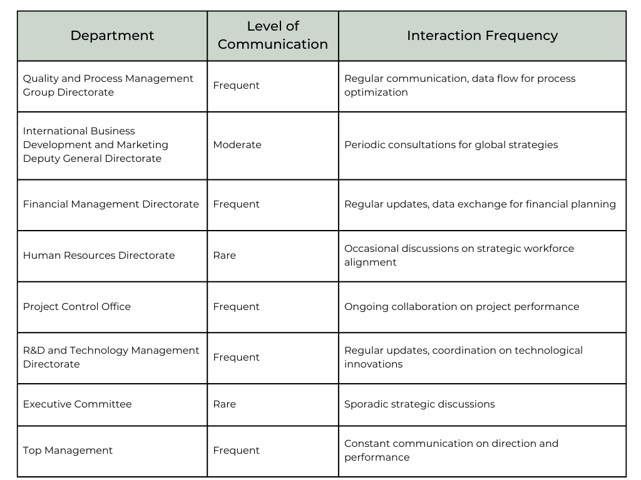

## 2.3 Existing Communication Tools and Protocols

### 2.3.1 Tools in Use

HAVELSAN utilizes a combination of digital and manual tools for communication, including digital platforms like SharePoint, cloud systems, and Evraka document management tools for document sharing and storage. Email serves as the primary method for daily data exchanges, while phone calls and communication apps are used as emergency channels for urgent discussions.

### 2.3.2 Communication Protocols

Communication involves structured processes with predefined procedures for reporting, data validation, and feedback collection; however, despite these formal protocols, a significant reliance on interpersonal relationships often introduces variability in communication efficiency.

## 2.4 Challenges in Interdepartmental Communication

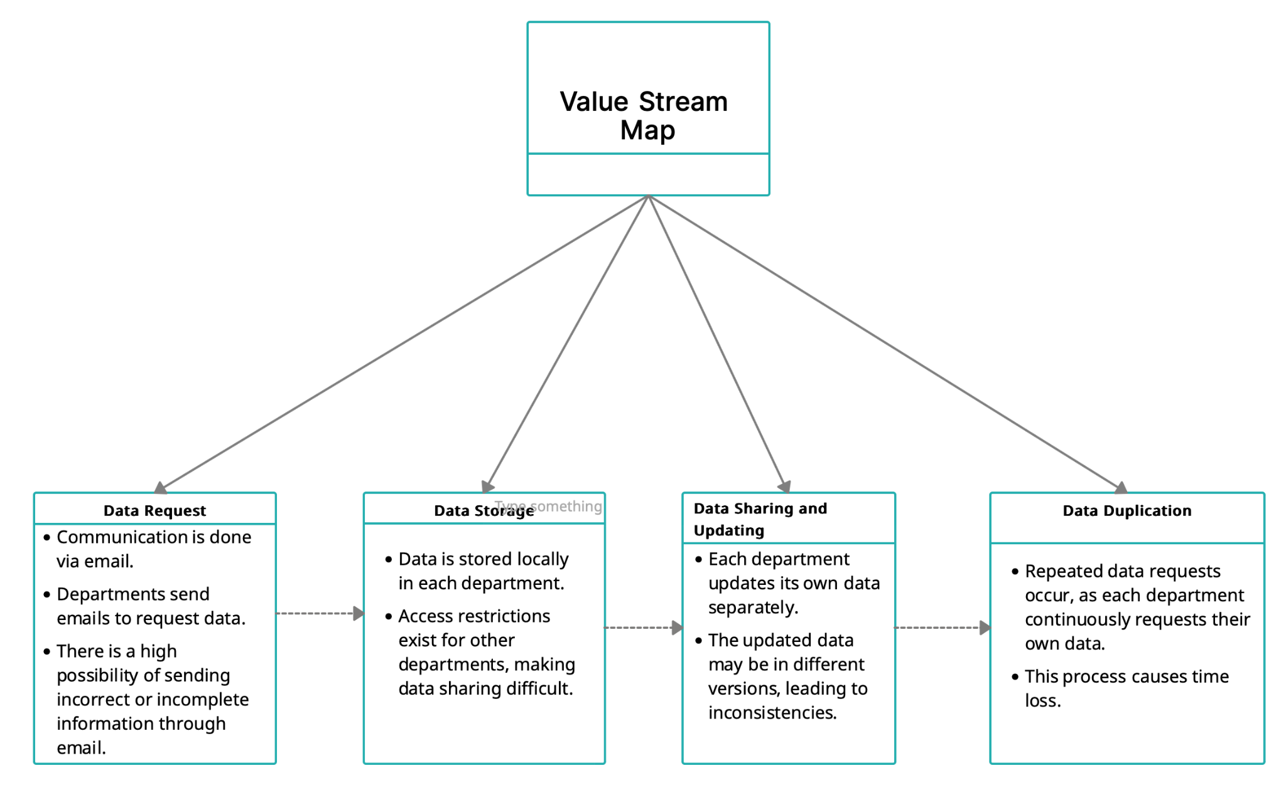

**Figure 1:** Value Stream Map

### 2.4.1 Lack of Centralization

One of the major bottlenecks is the absence of a unified communication system, as data is stored in localized silos within departments, resulting in restricted access to critical information and delays in data sharing and decision-making processes.

### 2.4.2 Manual Dependency

Reliance on emails and manual requests creates inefficiencies, including delays from back-and-forth email exchanges and errors caused by outdated or duplicate versions of documents.

### 2.4.3 Communication Gaps

The strategy department faces recurring issues with certain departments, particularly Quality and Process Management and Financial Management, as communication breakdowns lead to incomplete or delayed information exchanges, and employees frequently bypass formal channels, further complicating the flow of information.

### 2.4.4 Lack of Feedback Mechanisms

HAVELSAN lacks a structured system to measure communication efficiency, with no Key Performance Indicators (KPIs) in place to evaluate process effectiveness and no systematic collection of employee feedback on tools and workflows.

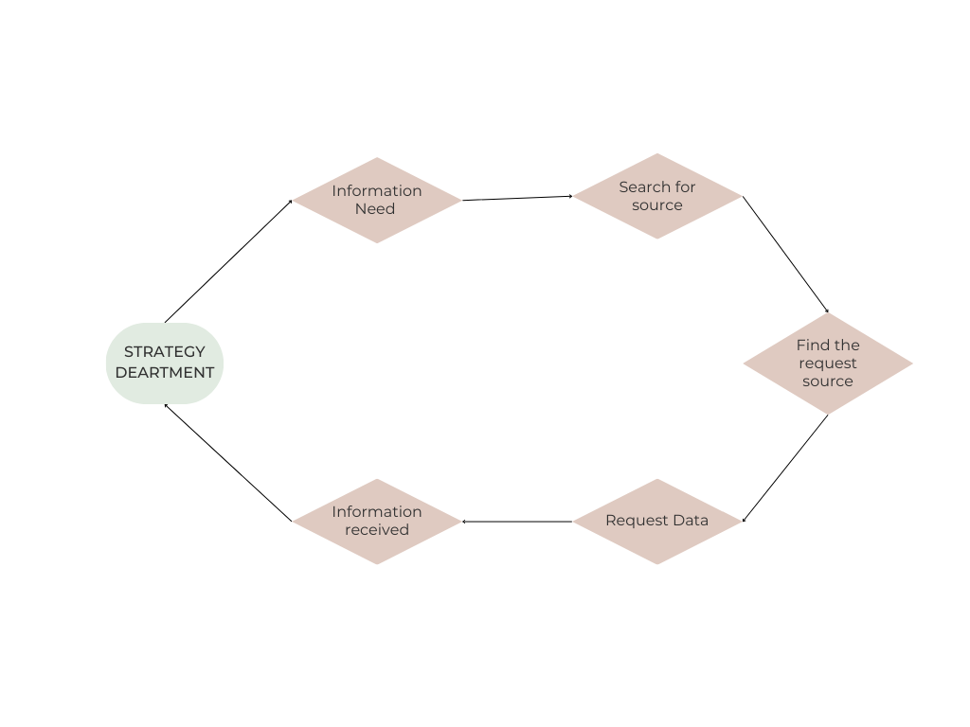

**Figure 2:** Cycle of Data Flow

## 2.5 Effects of Current Communication Issues

### 2.5.1 Operational Delays

Incomplete data and slow feedback loops cause project delays, while the inability to access real-time information hinders effective decision-making.

### 2.5.2 Increased Workload

Repeated data requests and redundant communication efforts waste valuable time and resources, while employees often address these inefficiencies through informal channels, leading to increased stress and workload.

### 2.5.3 Missed Opportunities

Communication breakdowns can lead to missed deadlines, unmet customer demands, and decreased operational effectiveness, while the lack of proper coordination can undermine collaboration between departments.

## 2.6 Summary of Current Situation

HAVELSAN’s strategy department operates under a fragmented communication system where efficiency is compromised by:

An over-reliance on manual processes and interpersonal relationships, the absence of centralized data-sharing platforms, and the limited use of performance metrics to track and improve communication workflows contribute to inefficiencies in the organization. These issues highlight the need for a systemic overhaul of the communication processes, focusing on integrating digital tools, automating workflows, and establishing standardized performance measurement systems. This foundation will pave the way for designing effective solutions to enhance interdepartmental collaboration and overall organizational efficiency.

# CHAPTER 3 LITERATURE REVIEW

In today's fast-paced and interconnected business world, organizations are increasingly recognizing the importance of interdepartmental collaboration. As companies strive to meet the challenges of globalization, technological advancements, and shifting market demands, effective cooperation between departments has become crucial. This section will explore the concept of interdepartmental collaboration, its significance within organizations, and how it contributes to overall organizational performance. By examining the definition and key elements of interdepartmental collaboration, we will provide a foundational understanding of why this practice is essential for success in modern organizations.

## 3.1 What is Interdepartmental Collaboration?

Interdepartmental communication is the exchange of information, ideas, and resources between different functional areas within an organization (Anderson et al., 2017) Effective collaboration is critical for organizations to leverage diverse expertise, align on common goals, and drive innovation. When integrated with core business units, non-core departments can amplify functionality and propel the organization forward. (Ren S and Wang Y (2024))

## 3.2 Importance of Interdepartmental Communication

Effective departmental collaboration is more important than ever in the fast-paced, globally networked business world of today. The process of coordinating and aligning activities across multiple functional domains to accomplish common corporate goals is known as interdepartmental collaboration. This strategy goes beyond conventional silos and promotes an integrated framework that makes use of a variety of resources and expertise to promote responsiveness, efficiency, and innovation.

Interdepartmental collaboration improves internal procedures and helps businesses better respond to the ever-evolving demands of the market by removing obstacles and promoting communication and cooperation. This section explores the core causes of interdepartmental collaboration's importance for contemporary businesses, emphasizing how it boosts overall organizational agility, encourages innovation, increases productivity, and facilitates well-informed decision-making.

Effective communication increases operational efficiency, improves decision-making processes, and increases customer satisfaction. However, lack of communication can slow down the flow of information between departments and disrupt business processes.

In a study, 97% of participants stated that interdepartmental communication is important, while only 34% think that their company has a healthy communication environment. This shows that communication deficiencies are common in organizations. (Yetimoglu,.2014)

Organizations must collaborate across departments since it has several advantages. Cross-functional collaboration can significantly increase productivity and efficiency by reducing redundancy, simplifying processes, and optimizing resources. It fosters innovation and leads to creative problem-solving by combining different perspectives and expertise. This fosters better decision-making by combining cross-functional insights and reducing functional bias. Additionally, cross-functional collaboration enables businesses to quickly adapt to changing consumer needs and increase organizational agility. Agile techniques foster collaboration and teamwork, creating a more productive and effective work environment. Overall, effective cross-functional collaboration can lead to significant improvements in productivity and efficiency.

## 3.3 Challenges and Barriers to Effective Collaboration

Effective collaboration is often hindered by a number of challenges, both organizational and interpersonal. One of the most obvious barriers in communication breakdowns. These can occur at multiple levels, both within teams and across departments or organizations. Miscommunication can lead to confusion, delays, and even conflict, undermining the overall efficiency and effectiveness of collaborative efforts. This can be due to differences in language, terminology, or expectations, especially when multiple organizations with different cultures and practices are involved. (Eide et al., 2012)

Another significant challenge is the difficulty of establishing shared situational awareness. When individuals or teams disagree on the same goals, context, or priorities, it becomes difficult to make coordinated decisions and take appropriate action. This lack of shared awareness can lead to individuals or groups pursuing different goals or not fully understanding the impact of their actions on others in the collaboration. Without a clear and unified understanding of the situation, the chances of achieving the desired results are greatly diminished.(Eide et al., 2012)

Additionally, there is often a lack of understanding across organizations. When organizations with different structures, values, and goals collaborate, there can be a lack of alignment in expectations or approaches. These differences can create friction as teams struggle to adapt to each other’s work styles, processes, and organizational cultures. The lack of a common framework for understanding across organizations can hinder the development of trust and mutual respect, which are essential for successful collaboration.(Eide et al., 2012)

As highlighted by Eide et al. (2012), these barriers can significantly impede the progress of collaborative efforts and make it difficult to achieve the desired synergy between teams or organizations. Overcoming these challenges requires coordinated efforts to foster clear communication, create shared understanding, and build interorganizational relationships based on trust and common goals.

Cognitive, power, and communication barriers are important barriers to effective interagency collaboration (Rouzbehani, 2020). Cognitive barriers refer to differences in how individuals or groups perceive and interpret information, which can lead to misunderstandings or incompatible goals. Power barriers occur when one organization or group has more influence or authority, creating an imbalance that affects decision-making and collaboration dynamics. Finally, communication barriers occur when there are difficulties in sharing information clearly and effectively due to language differences, technological issues, or different communication styles. All of these barriers can contribute to friction and reduce the effectiveness of collaborative efforts.

Contextual factors such as problem complexity, policy and political environments, collaboration capacity, and participant-related issues further complicate collaboration efforts (Margerum, 2016). Problem complexity occurs when the issue at hand is multifaceted and requires coordination of diverse stakeholders with diverse expertise and perspectives, making collaboration more challenging. Policy and political environments can introduce external influences that shape the direction and constraints of collaboration, including regulatory frameworks, funding, or political agendas that may not align with the goals of all parties involved. Collaborative capacity refers to the ability of organizations or teams to work effectively together, which can be hindered by a lack of resources, experience, or institutional readiness. Finally, participant-related issues include challenges that individual team members may face, such as differing motivations, conflicting priorities, or lack of trust, all of which can negatively impact the overall collaboration process.

Successful collaboration often requires a shared vision, strong leadership, and the ability to overcome technical, organizational, and personal barriers . A shared vision fosters a sense of purpose and direction that is critical to sustaining collaboration over time by ensuring that all participants are aligned toward the same goals. Strong leadership plays a vital role in guiding the collaboration process, providing clarity, resolving conflicts, and motivating team members to remain engaged. Technical barriers, on the other hand, can include challenges related to incompatible systems or lack of technical resources, which can prevent smooth interaction and information exchange. Organizational barriers include structural or cultural differences among collaborating entities that can hinder coordination or trust. Finally, personal barriers refer to individual challenges that can impact the effectiveness of collaboration, such as different communication styles, interpersonal conflicts, or varying levels of commitment.(Wasserman, 2015)

To overcome these challenges, researchers recommend using conceptual frameworks, visual thinking tools, and online collaboration platforms. Conceptual frameworks help provide a structured approach to understanding and analyzing complex problems and ensure that all stakeholders have a common reference point for decision-making and problem-solving. Visual thinking tools, such as diagrams, flowcharts, or mind maps, can improve communication and understanding by simplifying complex ideas and making information more accessible. These tools also facilitate better collaboration by allowing participants to visualize and align their thoughts. Online collaboration platforms enable seamless communication and coordination across teams, especially in geographically dispersed environments, allowing for real-time document sharing, discussions, and feedback. These platforms help overcome many logistical barriers and ensure that all participants are actively involved in the collaboration process. (Rouzbehani, 2020)

Additionally, being aware of potential barriers and planning proactively can significantly increase the chances of successful collaboration in a variety of areas, such as emergency management, public policy, and software development (Eide et al., 2012; Margerum, 2016). Being aware of potential barriers includes recognizing common challenges that may arise during collaboration, such as communication breakdowns, incompatible goals, or resource constraints. By understanding these barriers in advance, teams can prepare strategies to mitigate their impact. Proactive planning involves taking proactive steps to establish clear roles, set expectations, and implement mechanisms for ongoing communication and feedback. In areas where rapid and coordinated action is critical, such as emergency management, proactive planning ensures that all parties know their responsibilities and can respond quickly. In public policy, understanding the political and regulatory landscape in advance helps prevent conflict and align stakeholders. In software development, anticipating technical challenges and aligning development teams around a common vision can prevent delays and inefficiencies, leading to smoother collaboration. (Wasserman, 2015; Eide vd., 2012; Margerum, 2016)

## 3.4 How Global Organizations Manage Interdepartmental Collaboration

In large organizations, interdepartmental collaboration can be improved with a variety of approaches. One effective method is the use of visual planning techniques, such as graphical representations of workflows and timelines, which help make complex processes more understandable and transparent across departments (Prilop, 2012). By visualizing workflows, organizations can clearly depict how tasks flow between departments, identify potential bottlenecks, and ensure that everyone involved understands their role and responsibilities in the project. Timelines, on the other hand, help departments align their efforts and track progress by providing a clear schedule of milestones, deadlines, and deliverables. These visual tools promote better coordination, reduce misunderstandings, and enable more efficient project development by providing a shared, easily interpretable overview of the entire process.

Data-driven visualization tools can uncover potential collaborators based on publication data and researcher profiles, thus supporting interdisciplinary partnerships . These tools leverage large datasets of academic publications, citations, and researcher expertise to identify individuals or teams with complementary skills and interests. By visually mapping this information, researchers can easily identify opportunities for collaboration across fields or organizations. Such tools can highlight important researchers, emerging trends, or underexplored areas that could benefit from interdisciplinary input. This approach not only fosters new partnerships, but also improves the quality of research by bringing together different perspectives and expertise from multiple disciplines, ultimately advancing innovation and knowledge exchange. (Yazdi et al., 2016)

Research shows that interdepartmental collaboration has a stronger positive impact than simple interaction through meetings and information exchange (Kahn, 1996). Effective collaboration involves more than just exchanging information; it requires deep involvement, shared decision making, and active problem solving across teams. When departments work closely together, pooling their expertise and resources, they can innovate more effectively and address challenges holistically. This level of collaboration fosters a sense of ownership and accountability, leading to better product development results. On the other hand, simply holding meetings or exchanging information without structured, meaningful interaction often results in fragmented efforts that do not contribute to improved performance because different departments may not align their goals or fully integrate their work processes.

Advanced technologies, especially big data, offer new opportunities for cross-organizational collaboration by providing transparency and enabling the automation of routines. The use of big data allows organizations to share real-time insights, monitor performance across departments, and identify areas for improvement or patterns that might otherwise be overlooked. This level of transparency fosters a more efficient exchange of information and improves decision-making and coordination by ensuring that all collaborators are on the same page. In addition, automation of routine tasks streamlines processes, reduces human error, and frees up resources for more strategic activities.

However, while technological embedding can facilitate collaboration, it can also limit the development of interpersonal trust and strategic learning (Cepa & Schildt, 2018). Over-reliance on technology can be a barrier to the direct, face-to-face communication that is crucial for building trust among team members. Trust is often built through shared experiences, informal conversations, and the ability to read nonverbal cues—elements that are harder to achieve through technological means. Additionally, strategic learning, which involves understanding broader organizational goals and adjusting strategies accordingly, can be hindered when teams over-rely on automated systems that fail to fully capture the nuances of strategic insight or adaptive decision-making.

Overall, successful cross-functional collaboration requires a careful balance of visual tools, data-driven approaches, and collaborative practices, as well as careful consideration of how technological integration is implemented. While technology can enhance the collaboration process, it’s crucial not to neglect the human aspects of collaboration, such as trust-building and strategic learning, to ensure long-term success.

## 3.5. Leveraging SSADM for Improved Interdepartmental Communication and Collaboration

Structured Systems Analysis and Design Methodology (SSADM) has been instrumental in improving interdepartmental collaboration within organizations. By providing a standard framework for systems development, SSADM facilitates clear communication and understanding among the various departments involved in a project. This methodology emphasizes detailed documentation and modeling techniques that help align the goals and expectations of different stakeholders. For example, the use of data flow diagrams and entity-relationship models in SSADM allows departments to visualize system processes and data interactions, promoting shared understanding and reducing miscommunication. (Rana, M. (2000))

Additionally, SSADM’s structured approach helps identify and resolve potential issues early in the development process, thus preventing conflicts that may arise from interdepartmental misunderstandings. By involving representatives from various departments during the analysis and design phases, SSADM ensures that system requirements are comprehensive and take into account the perspectives of all stakeholders. This collaborative involvement results in systems that are more aligned with organizational needs and facilitates smoother implementation and adoption across departments. (Thackeray, L. R. (2023))

In summary, SSADM serves as a valuable tool for encouraging interdepartmental collaboration by providing a clear and structured framework for systems development. Its emphasis on detailed documentation, standardized modeling techniques, and early stakeholder involvement helps align departmental goals, improve communication, and ensure the development of systems that meet the comprehensive needs of an organization.

## 3.6 TRIZ Methodology for Strengthening Interdepartmental Cooperation

The paper by Jiang et al. (2011) explores how TRIZ, a problem-solving methodology, can improve interdepartmental collaboration and knowledge transfer, particularly in the context of government administration. The study highlights the potential of TRIZ to facilitate decision making and resolve conflicts in policy implementation. By systematically addressing problems, TRIZ provides a structured approach to overcoming challenges, encouraging interdepartmental collaboration, and enabling solutions to integrate more seamlessly.(Jiang et al., 2011)

TRIZ’s systematic approach, which includes both abstraction and development of concrete solutions, can be integrated with other methodologies such as ARIS or WOIS to improve organizational processes. This integration helps facilitate problem solving and increase overall efficiency across departments by providing structured frameworks. (Moehrle, 2005)

Schöfer et al. (2013) show that TRIZ and its derivatives are effective tools for promoting knowledge sharing and transfer in interdisciplinary teams, especially during face-to-face problem-solving sessions. The collaborative nature of TRIZ facilitates the exchange of ideas and expertise, enabling teams to tackle complex challenges more efficiently. By integrating diverse perspectives, TRIZ encourages creative solutions and improves team dynamics.(Schöfer et al., 2013)

## 3.7 Lean Methodology in Communication Systems

Lean principles can significantly increase interdepartmental collaboration and improve organizational performance. The implementation of Deming quality management approaches has been shown to positively impact perceptions of interdepartmental collaboration (Collard, 1993). Interdisciplinary training in lean principles prepares future employees to add immediate value to their companies by solving real-world problems (Til et al., 2009; Til et al., 2005). This approach involves collaborative projects between academia and industry and encourages diverse perspectives on lean manufacturing (Til et al., 2005). In healthcare settings, collaborative lean methodologies have improved interprofessional work and coordination of care, reduced hospital lengths of stay, and optimized patient flow (Blouin-Delisle et al., 2020). These projects demonstrate how diverse professionals can move from shared decision-making to collaborative workflows by co-designing processes. Key elements of successful lean implementation include effective communication, role clarification, and professional autonomy throughout the patient care journey (Blouin-Delisle et al., 2020).

## 3.8 Literature Gaps and Research Opportunities

Despite the growing body of research on methodologies like TRIZ, SSADM, and Lean in business process optimization, certain gaps remain, particularly in their application to the defense sector. While TRIZ has been extensively explored in product design, its potential for resolving contradictions in organizational communication is under-researched.

This study aims to fill these gaps by examining how TRIZ can be applied to address communication contradictions between departments, specifically in defense-related digital systems. Further research in this area could lead to more refined methodologies for improving interdepartmental communication and collaboration, particularly through digital systems.

# CHAPTER 4 METHODOLOGY OVERVIEW

# In this study, a combination of Lean, Agile and TRIZ (Theory of Resheniya Izobretatelskikh Zadach) methods will be used to solve the identified problem. Below, the main features of each methodology, their applicability and how to integrate them into our work process are summarized.

## 4.1 TRIZ (Theory of Inventive Problem Solving)

To address these issues, the 40 Creative Principles of TRIZ were consulted and principles 1 and 35 were selected based on their relevance and effectiveness. It is supported by an academic paper that explains in detail the 40 principles of TRIZ according to its academic paper. The applicability of these principles is discussed in detail below:

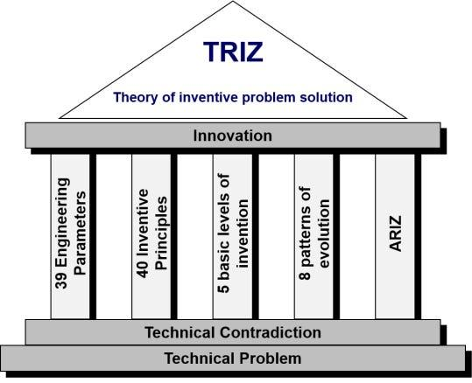

**Figure 3:** Theory of Inventive Problem Solution

The Segmentation Principle **(Principle 1)** emphasizes dividing a system or process into smaller, manageable parts to create a more flexible and efficient structure. In the context of improving interdepartmental data sharing, this principle can be applied through the implementation of a centralized data management platform where data is segmented according to the specific needs of each department. This approach addresses the issue of local data storage by centralizing all data and ensuring that each department accesses only the information it requires, thereby eliminating redundancies and inconsistencies caused by multiple versions of data. By enabling streamlined and accurate access to information, segmentation minimizes error risks and enhances overall efficiency in data management and communication.

The Parameter Change Principle **(Principle 35)** focuses on optimizing existing system parameters to create innovative solutions. Applying this principle involves enhancing the company's current email and file-sharing infrastructure by integrating a centralized data management system with version control capabilities. This transformation replaces local data storage, addressing the issue of inconsistent data caused by multiple versions, while simultaneously leveraging existing infrastructure to reduce the cost and complexity of implementing new systems. By optimizing resources, this approach ensures consistent data sharing, improves communication accuracy, and enhances overall operational efficiency.

The proposed solutions, grounded in TRIZ principles 1 and 25, offer significant advantages, including time and workforce savings by eliminating inefficiencies caused by email-based communication and repetitive data requests. They also ensure consistent and reliable data management through a centralized system that addresses inconsistencies stemming from multiple data versions. Additionally, by optimizing existing systems, these solutions achieve high efficiency at a lower cost.

## 4.2. Lean Approach

The Lean method is a management and production philosophy based on continuous improvement and employee participation, aiming to create maximum value for the customer by minimizing waste in the value stream.

The objective is to minimize waste and optimize processes by eliminating non-value-adding activities, focusing on improving communication workflows to enhance the overall flow of value. This involves analyzing existing processes through Value Stream Mapping to identify delays, inefficiencies, and waste, particularly those caused by email-based communication and repetitive data requests that negatively impact workforce efficiency. By addressing these issues, the plan aims to streamline communication, eliminating redundant steps and errors to create a system that is both faster and more accurate. The expected outcome of these efforts is the development of processes that are not only cost-effective but also customer-focused, fostering an environment where value delivery is prioritized and operational efficiency is significantly improved.

### 4.2.1. Value Stream Mapping (VSM):

Value stream mapping is a lean management tool used to analyze and improve existing processes. This method involves mapping the flow of information step by step to identify bottlenecks, delays, and unnecessary workloads. For instance, in the email-based data request process, steps such as "Creating a data request → Sending an email → Waiting for a response from the department → Retrieving data from a local system" are examined. This analysis reveals inefficiencies and waste in communication processes. To address these issues, implementing a centralized data management system is recommended. Such a system enables real-time access for departments, eliminating email traffic and accelerating information flow.

### 4.2.2. 5S Methodology:

The 5S methodology is a five-step approach designed to streamline processes by maintaining workplace organization. The first step, "Sort," identifies and eliminates unnecessary and unused data flows in the process. In the "Set in Order" phase, a centralized data repository is created, organizing data based on departmental priorities. The "Shine" step focuses on removing duplicate data versions and improving data consistency. "Standardize" ensures that all departments use a standardized system for data sharing. Finally, the "Sustain" step involves regular checks and improvements to ensure the system's sustainability. Implementing these steps resolves communication inefficiencies while making data flow organized, fast, and error-free.

**Table 2:** Success factors in the implementation of Lean computing in the BT sector

metin, ekran görüntüsü, sayı, numara, yazı tipi içeren bir resim

Açıklama otomatik olarak oluşturuldu

## 4.3 Agile Methodology

The objective is to enhance flexibility and speed by quickly adapting to changes and developing solutions iteratively. This involves fostering team collaboration, creating continuous improvement cycles, and integrating user feedback into the process. The implementation plan includes iterative development, where solutions are prototyped, tested, and refined over time; gathering employee feedback to ensure the system's user-friendliness; and adopting a Scrum approach, where a cross-functional team addresses interdepartmental communication and data management issues through defined sprints. The action steps focus on setting short-term goals to advance solution development, such as completing a module of the platform design. This approach aims to enable rapid adaptation to evolving conditions and the delivery of high-quality outputs within shorter timeframes.

In the Scrum framework, sprint planning encourages addressing communication issues by replacing email chains with collaborative tools such as Jira or Confluence and breaking down processes into smaller, actionable tasks.

### 4.3.1. Agile Performance Metrics and Their Applications

Agile performance metrics play a crucial role in tracking and optimizing processes to improve productivity, quality, and team performance. Lead Time measures the duration from the initiation of a data request to its resolution, with a decrease indicating improved efficiency. Cycle Time tracks the duration of specific tasks, such as responding to a data request, helping assess communication speed and effectiveness. Work in Progress (WIP) monitors the number of tasks being worked on, identifying potential bottlenecks and ensuring smooth workflow. The Cumulative Flow Diagram (CFD) visualizes task movement through stages, enabling quick identification of bottlenecks and providing data for workflow optimization. Employee Satisfaction is measured through feedback on communication tools and processes, helping enhance organizational change and engagement. Finally, the Error Rate tracks the number of errors or inconsistencies in shared data, allowing for the identification of areas requiring improvement. By tracking and analyzing these metrics, organizations can evaluate the effectiveness of Agile practices, optimize workflows, and improve communication processes.

# CHAPTER 5 CONCLUSION AND NEXT STEPS

This report provides a comprehensive analysis of the key challenges surrounding interdepartmental communication and data sharing processes at Havelsan. Inefficient email-based communication, reliance on manual processes, and a lack of centralization have created communication gaps, resulting in delays, data inconsistencies, and workforce inefficiencies. The current fragmented communication structure disrupts decision-making processes and negatively impacts interdepartmental collaboration. Utilizing an integrated approach that incorporates Lean, Agile, and TRIZ methodologies, this report aims to establish a foundation for designing an effective solution to optimize communication workflows, reduce manual dependencies, and enhance interdepartmental collaboration.

The next steps of the project are structured to address the identified communication challenges. The process begins with designing and implementing a comprehensive survey to collect feedback and insights from relevant departments regarding current inefficiencies and communication gaps. This data collection phase is critical for gaining a deeper understanding of pain points and ensuring that subsequent steps align with organizational needs. The collected data will be analyzed to validate and refine the problem definition, focusing on specific bottlenecks and inefficiencies hindering interdepartmental collaboration.

Based on this analysis, a solution framework will be designed by integrating the principles of TRIZ, Lean, and Agile methodologies. TRIZ principles, such as segmentation and parameter modification, will support the solution development process, while the Lean approach will aim to eliminate waste in value stream maps and simplify processes. The Agile methodology will ensure faster and more flexible teamwork, accelerating the value stream and improving operational efficiency. The proposed solution will prioritize digital tool integration, workflow automation, and robust performance measurement systems, tailored to align with Havelsan’s strategic goals.

Finally, the proposed solution will undergo a pilot implementation to evaluate its effectiveness in resolving data-sharing bottlenecks and enhancing interdepartmental collaboration. Through this iterative and systematic approach, the project aims to streamline communication workflows, foster collaboration, and ultimately deliver a transformative solution that strengthens Havelsan’s organizational efficiency.

# REFERENCES

1. Molchanov, E.G., Musaelyan, A.K., Mikhaylenko, R.G., & Smertina, E.N. (2019). Dependence of the Process of Decision Making in Modern Business Systems on Their Organizational Structure. Specifics of Decision Making in Modern Business Systems.
2. Ajagbe, A.M., Bih, J., Olujobi, J.O., & Udo, E.E. (2016). Which Precedes the other? Organizational Strategy orOrganizational Structure.
3. HAVELSAN DEFENSE INDUSTRIES AND TRADE INC. . Official website. <https://www.havelsan.com/tr>
4. Ren S and Wang Y (2024) Bridging the gap: unleashing the power of non-core departments through interdepartmental collaboration. Front. Psychol. 14:1275666.
5. Lauren, B. S. (2015). Mapping the Workspace of a Globally Distributed “Agile” Team. International Journal of Sociotechnology and Knowledge Development (IJSKD), 7(2), 45-62.
6. H. J. Thamhain, "Managing Cross-Functional Integration of Complex Developments," 2006 Technology Management for the Global Future - PICMET 2006 Conference, Istanbul, Turkey, 2006, pp. 2598-2606, doi: 10.1109/PICMET.2006.296858.
7. Yetimoglu,. 2014, March 13). Communication breakdowns in interdepartmental communication.
8. Eide, A.W., Haugstveit, I.M., Halvorsrud, R., Skjetne, J.H., & Stiso, M.E. (2012). Key challenges in multi-agency collaboration during large-scale emergency management.
9. Rouzbehani, R. (2020). Let's collaborate but how: Discussing collaboration barriers and opportunities in the digital era. Canadian Public Administration.
10. Margerum, R.D. (2016). Theoretical perspectives on the challenges of collaboration.
11. Wasserman, A.I. (2015). Barriers and pathways to successful collaboration. Companion to the Proceedings of the 11th International Symposium on Open Collaboration.
12. Rouzbehani, R. (2020). Let's collaborate but how: Discussing collaboration barriers and opportunities in the digital era. Canadian Public Administration.
13. Wasserman, A.I. (2015). Barriers and pathways to successful collaboration. Companion to the Proceedings of the 11th International Symposium on Open Collaboration.
14. Eide, A.W., Haugstveit, I.M., Halvorsrud, R., Skjetne, J.H., & Stiso, M.E. (2012). Key challenges in multi-agency collaboration during large-scale emergency management.
15. Margerum, R.D. (2016). Theoretical perspectives on the challenges of collaboration.
16. Yazdi, M.A., Valdez, A.C., Lichtschlag, L., Ziefle, M., & Borchers, J.O. (2016). Visualizing Opportunities of Collaboration in Large Research Organizations. Interacción.
17. Prilop, V. (2012). Collaborative Project Development in the Creation of an Interdepartmental Digitization Workflow. Collaborative Librarianship, 4, 60-66.
18. Kahn, K.B. (1996). Interdepartmental Integration: A Definition with Implications for Product Development Performance. Journal of Product Innovation Management, 13, 137-151.
19. Cepa, K., & Schildt, H.A. (2018). Technological Embeddedness of Inter-organizational Collaboration Processes. Managing Inter-organizational Collaborations: Process Views.
20. (Rana, M. (2000). Chapter 4: Development of Information Systems (TM). Retrieved from,[University of Houston )](https://uh.edu/)
21. Thackeray, L. R. (2023). A Novel Interdepartmental Approach to Teach Cross-Functional Collaboration in Software Engineering.Baltimore Convention Center, MD
22. Jiang, J., Chou, Y., & Sun, P. (2011). A new method of using TRIZ for problem solving and improvement design for a government department. Journal of the Chinese Institute of Industrial Engineers, 28, 155 - 164.
23. Moehrle, M.G. (2005). What is TRIZ? From Conceptual Basics to a Framework for Research. Wiley-Blackwell: Creativity & Innovation Management.
24. Schöfer, M., Maranzana, N., Aoussat, A., & Bersano, G. (2013). Testing the value of TRIZ and its derivatives for knowledge transfer in problem solving attempts by multidisciplinary teams.
25. Collard, E. (1993). The impact of deming quality management on interdepartmental cooperation. Human Resource Development Quarterly, 4, 71-79.
26. Til, R.P., Tracey, M.W., Sengupta, S., & Fliedner, G. (2009). Teaching Lean with an Interdisciplinary Problem Solving Learning Approach. International Journal of Engineering Education, 25, 173-180.
27. Til, R.P., Sengupta, S., Fliedner, G., Tracey, M.W., & Yamada, K. (2005). Teaching lean manufacturing principles using an interdisciplinary project featuring industrial/academic cooperation. Proceedings Frontiers in Education 35th Annual Conference, S2J-28.
28. Blouin-Delisle, C.H., Drolet, R., Hains, M., Tailleur, L., Allaire, N., Coulombe, M., & Vézo, A. (2020). Improving interprofessional approach using a collaborative lean methodology in two geriatric care units for a better patient flow. Journal of Interprofessional Education and Practice, 19, 100332.
29. Joshi, A., Shavers, M.C. & Milne, E. Interdepartmental Collaboration Model: A Support Strategy to Retain International Faculty in Counselor Education and Supervision. Int J Adv Counselling 45, 170–188 (2023).
30. Seraia, E., & Seryi, A. (2016). Accelerating Science TRIZ inventive methodology in illustrations.
31. Gürsev, S. (2022). Roadmap proposal for agile organizational transformation. FBU-DAE, 2(3), 265-274.
32. Tanriverdi, M. (2024). A literature review and application examples on the concept of lean computing. *3rd Sector Social Economy Journal*.